# Lab 1 - Load and Query Data in an Amazon Redshift Cluster

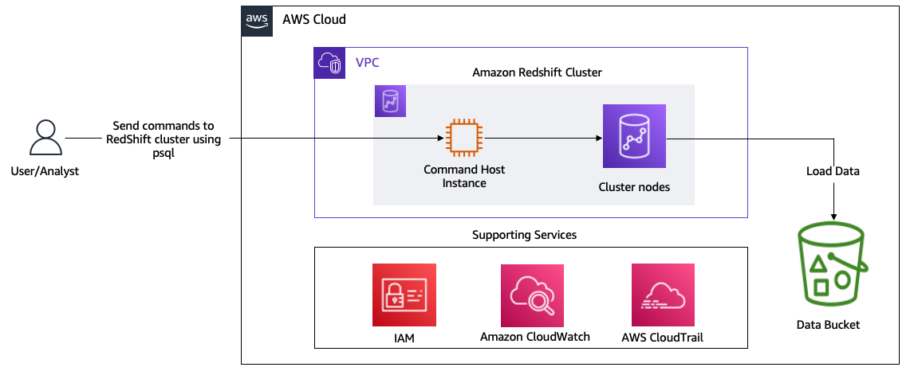

1. Create an Amazon Redshift cluster.
2. Load data into the cluster.
3. Use psql to query data in the cluster using the Command Host instance.
4. Open CLI, there we will run commands
5. Open s3, under this address-
   1. 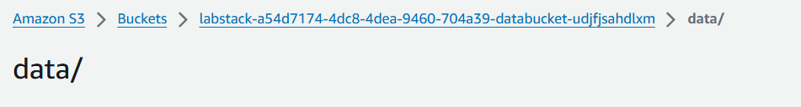
6. Open this-
   1. 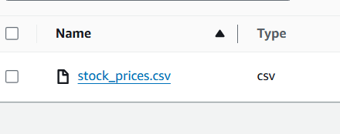
   2. 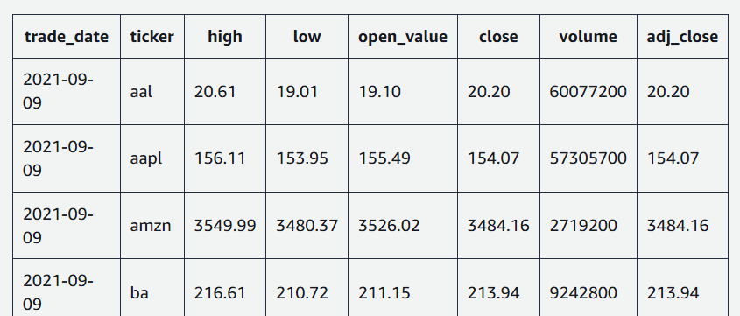

**Task 2: Set up a subnet group and parameter group**



2.1 open RS

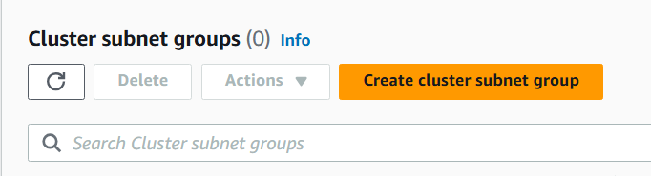

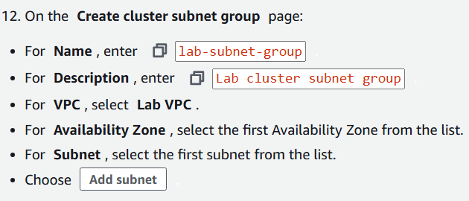

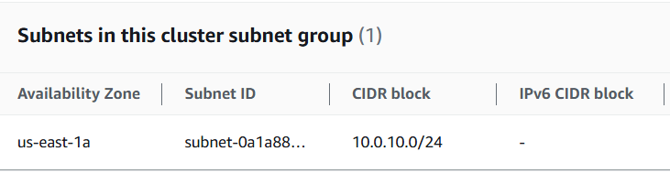



A cluster subnet group in Amazon Redshift is a collection of subnets within a VPC that defines the network boundaries for Redshift cluster deployments.

2.2 Create a cluster parameter group

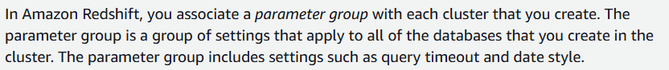

Under workload mgmt-

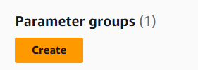

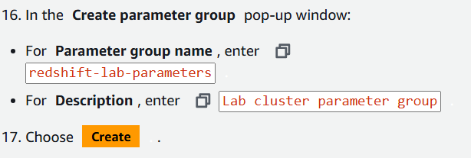

Open the created PG -

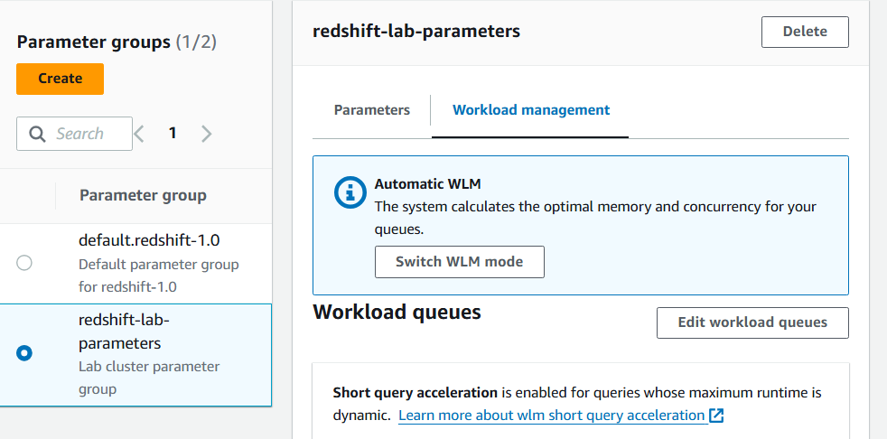

To edit -

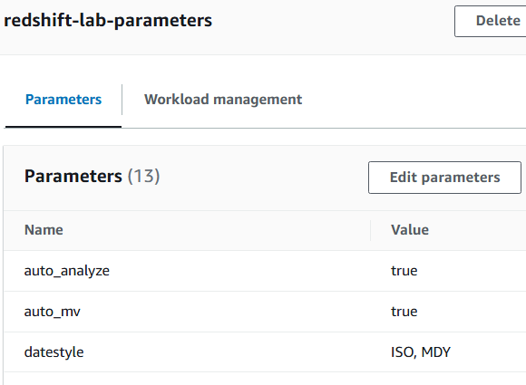



**Task 3: Create an Amazon Redshift cluster**

3.1 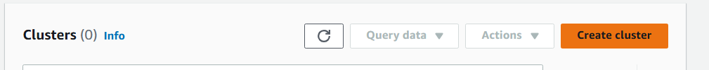

3.2 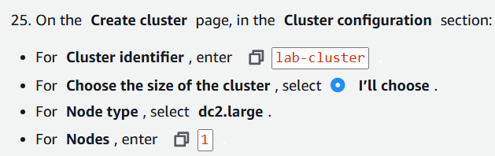

3.3 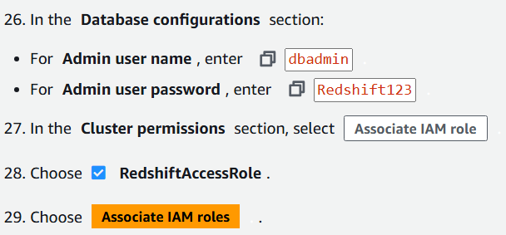

3.4 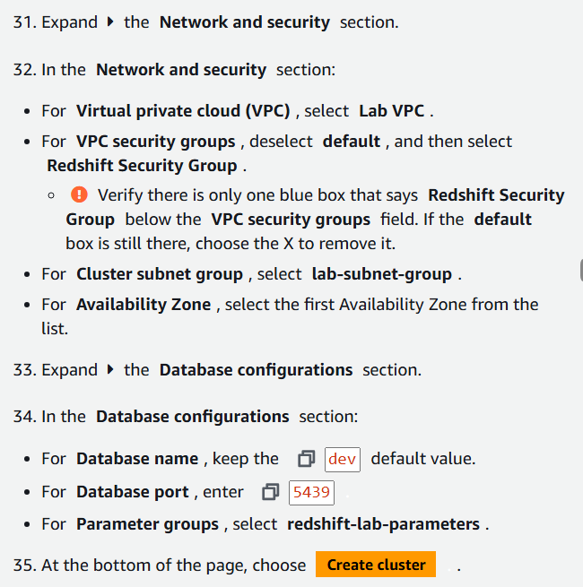

3.5 link with task 2 -

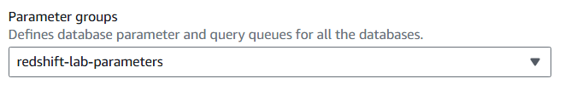

**Task 4: Load data to the Amazon Redshift cluster**

4.1 open CLI, run this

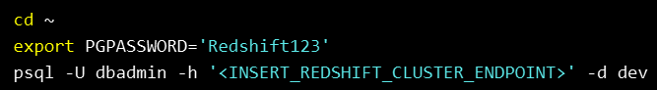

Replace endpoint value with cluster

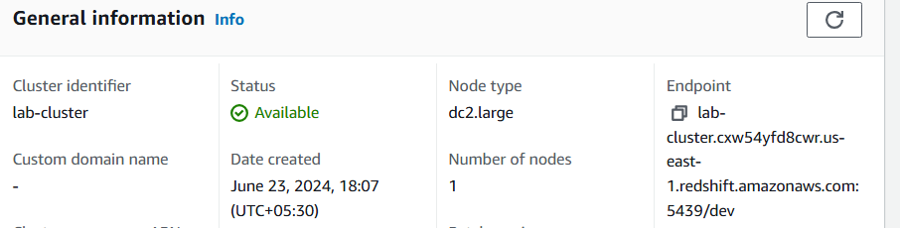

4.2 run queries

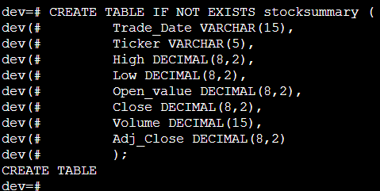

4.3 use “\dt” to show tables

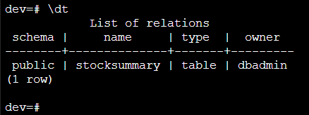

4.4 import from S3

COPY stocksummary

FROM 's3://INSERT_DATA_BUCKET_NAME/data/stock_prices.csv'

iam_role 'INSERT_REDSHIFT_ROLE'

CSV IGNOREHEADER 1;

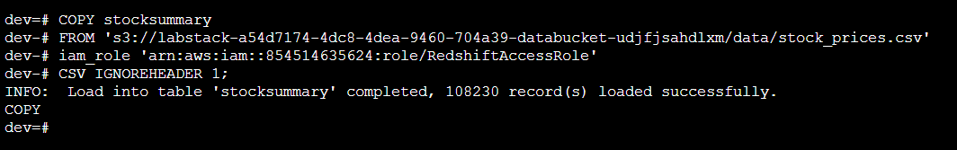

4.5 check

SELECT * FROM stocksummary WHERE Trade_Date LIKE '2020-01-03' ORDER BY Ticker;

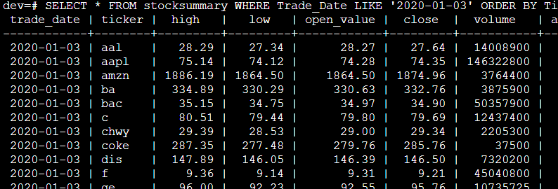

Lab had more queries.